Project Design Phase
Solution Architecture

Date | 30 October 2026
Team ID | Individual project
Project Name | Book a Doctor – Doctor Appointment Booking System
Maximum Marks | 4 Marks

Solution Architecture:
Book a Doctor follows a client-server architecture. Patients, doctors, and administrators use a React web interface that communicates with an Express REST API. The backend processes requests and stores application data in MongoDB.
- Separate screens support patient booking, doctor appointment management, and administrator user and doctor approvals.
- React Router manages frontend navigation, and Axios sends requests to the user, doctor, and admin API routes.
- Express controllers handle application operations. JWT middleware protects routes, while Mongoose manages Users, Doctors, and Appointments data in MongoDB.
- Multer handles appointment document uploads and stores them in the application uploads directory. Appointment status updates and notifications are also supported.

Solution Architecture Diagram:

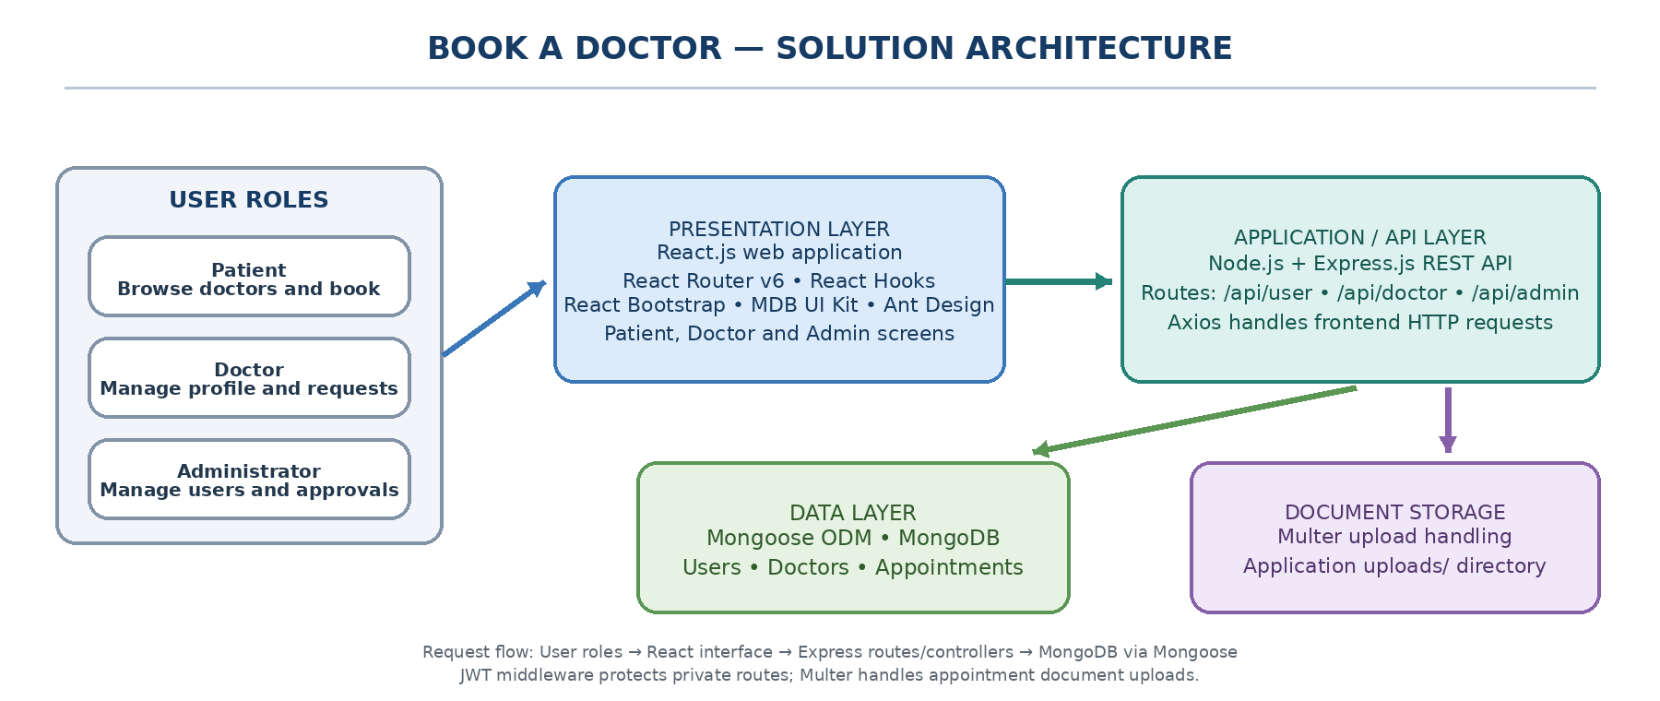
Figure 1: Solution architecture and request flow of the Book a Doctor application

